ơ–

**FPT ACADEMY INTERNATIONAL**

**FPT – APTECH COMPUTER EDUCATION**

Centre name: ACE-HCMC-2-FPT

Address: 590 Cach Mang Thang Tam, ward 11, district 3, Ho Chi Minh city

User manual

Step 1: download xampp

Please open this link : <https://www.apachefriends.org/download.html>

choose version 8.0.28

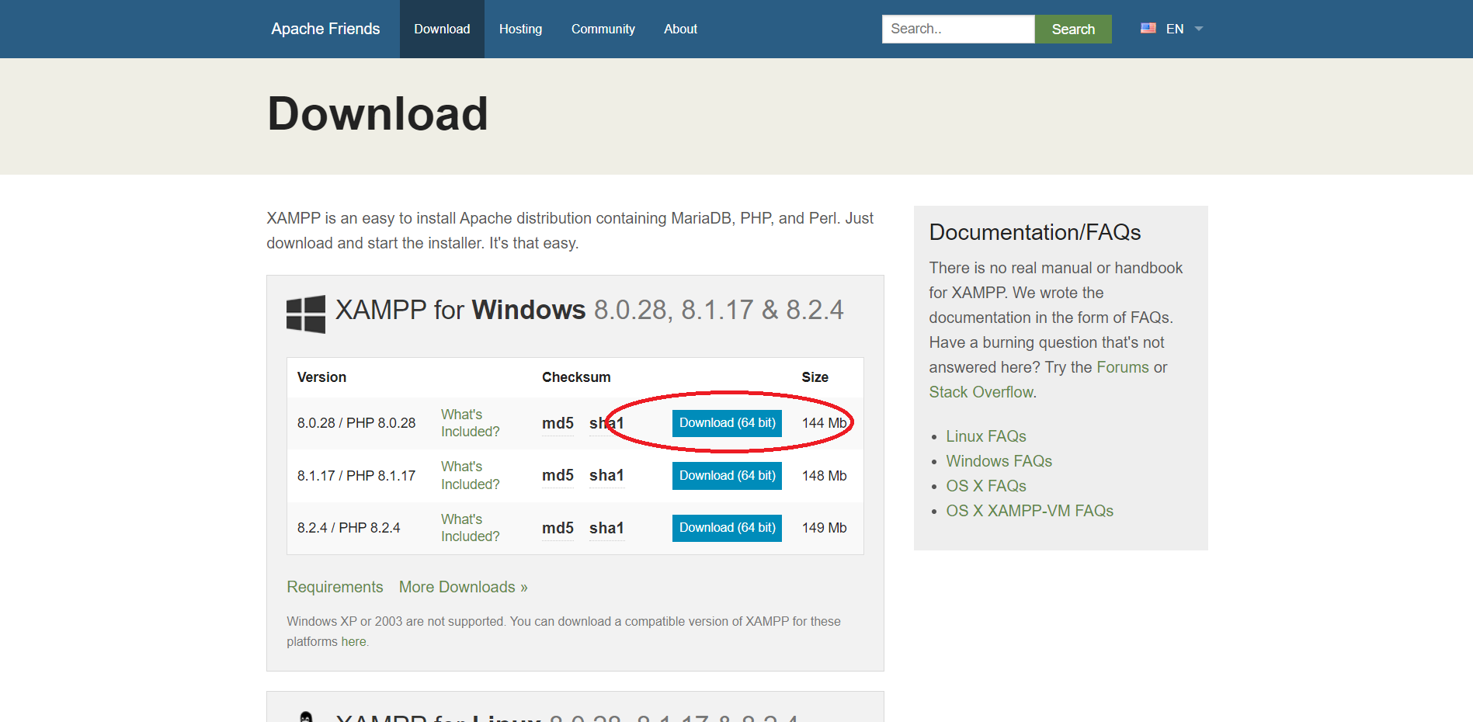

Click the OK button.

Click the Next button.

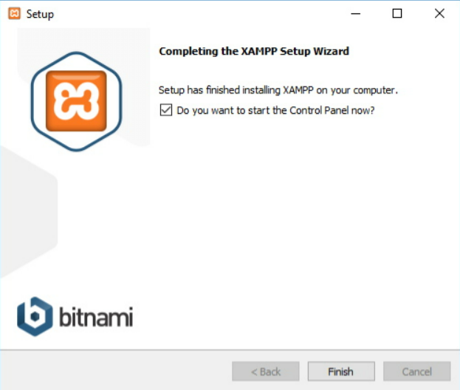

XAMPP provides various components that you can install, such as MySQL, phpMyAdmin, PHP, Apache, etc. In most cases, you will use most of these, because so you should leave the default options.

Click the Next button.

Use the default installed location. (Or choose a different folder to install the software in the Select a folder field).

Click the Next button.

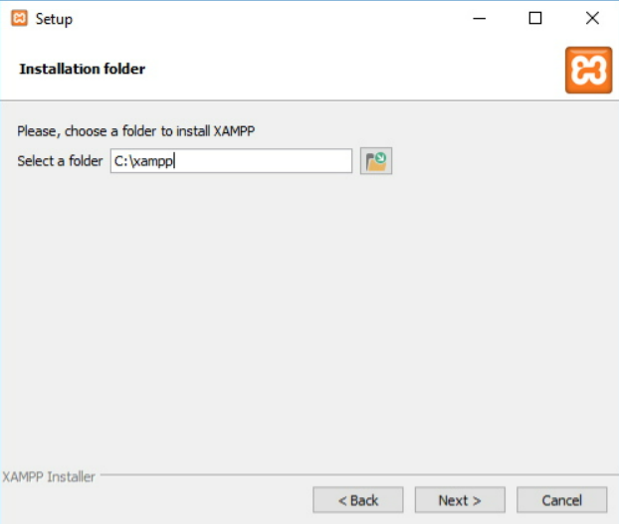

Select the language for the XAMPP Control Panel.

Click the Next button.

Remove the Learn more about Bitnami for XAMPP option.

Click the Next button twice.

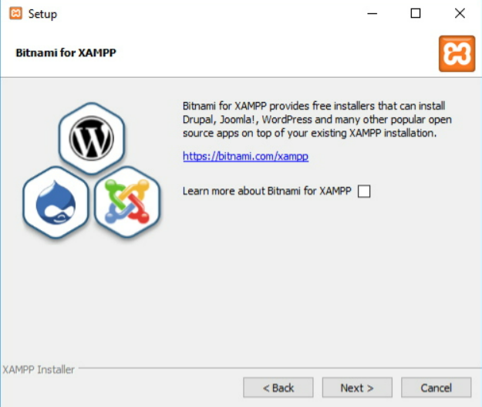

Click the Allow access button to allow the application through the Windows Firewall (if available).

Click the Finish button.

Step 2: set up xampp

Start apache, MySql

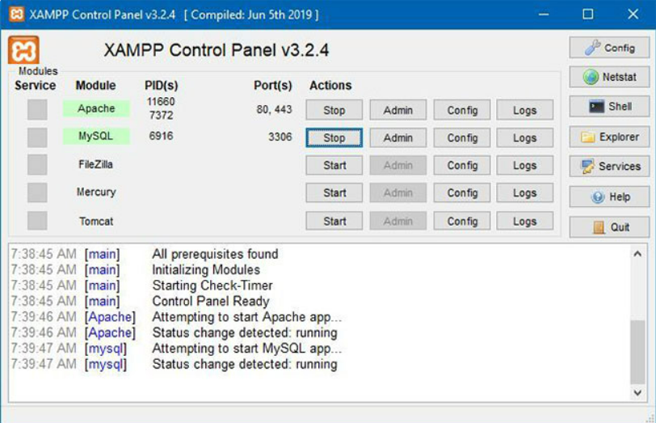

-return to the This PC and open the C drive.

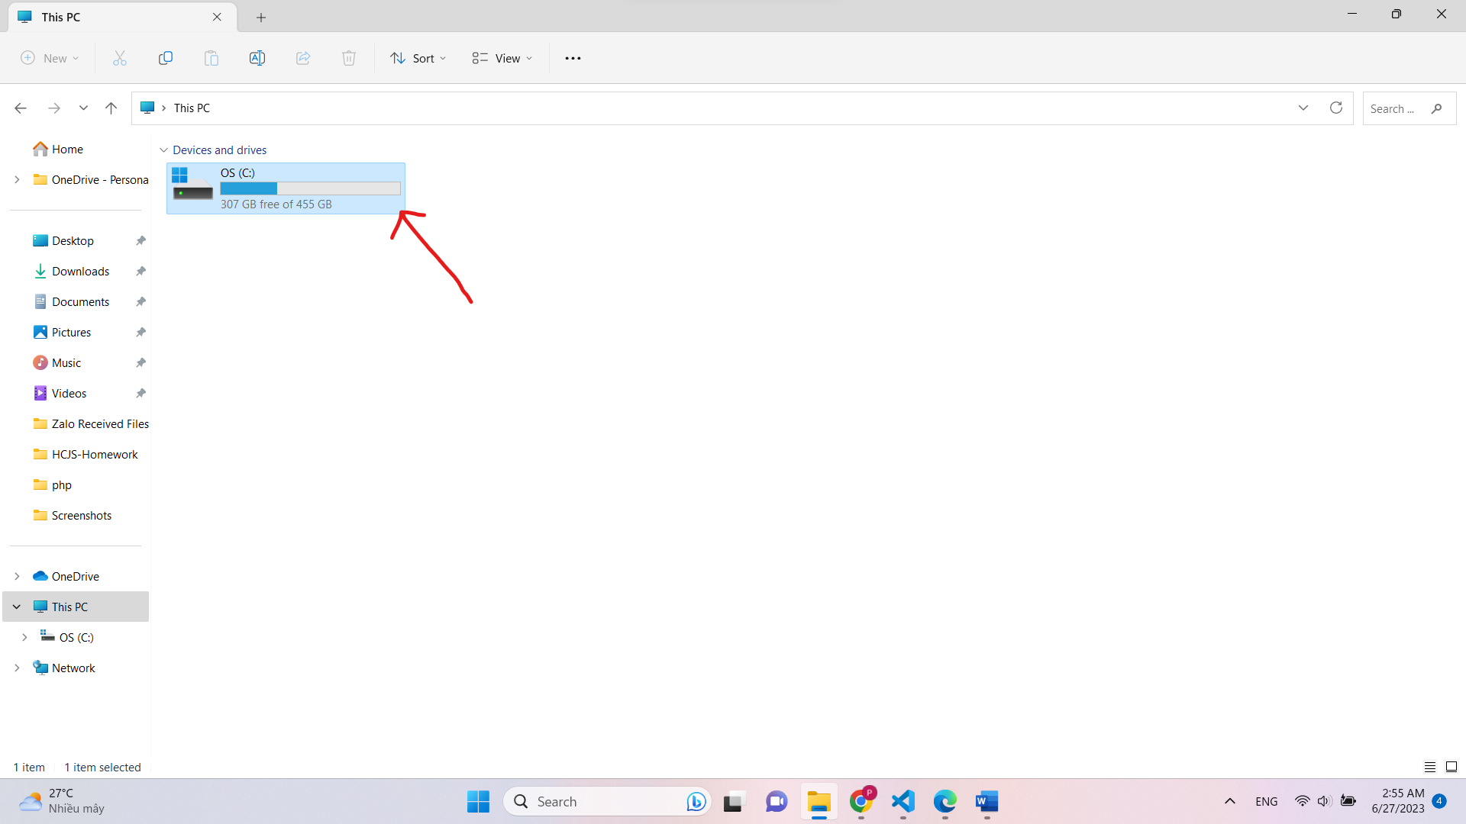

-open folder xampp

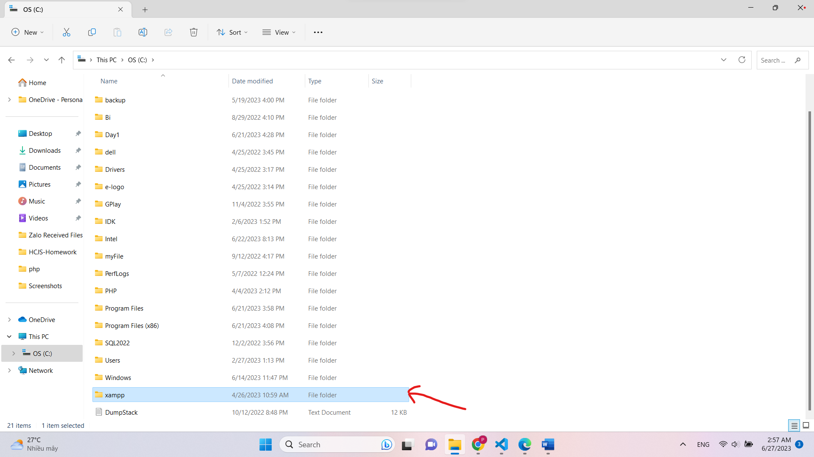

-open folder php

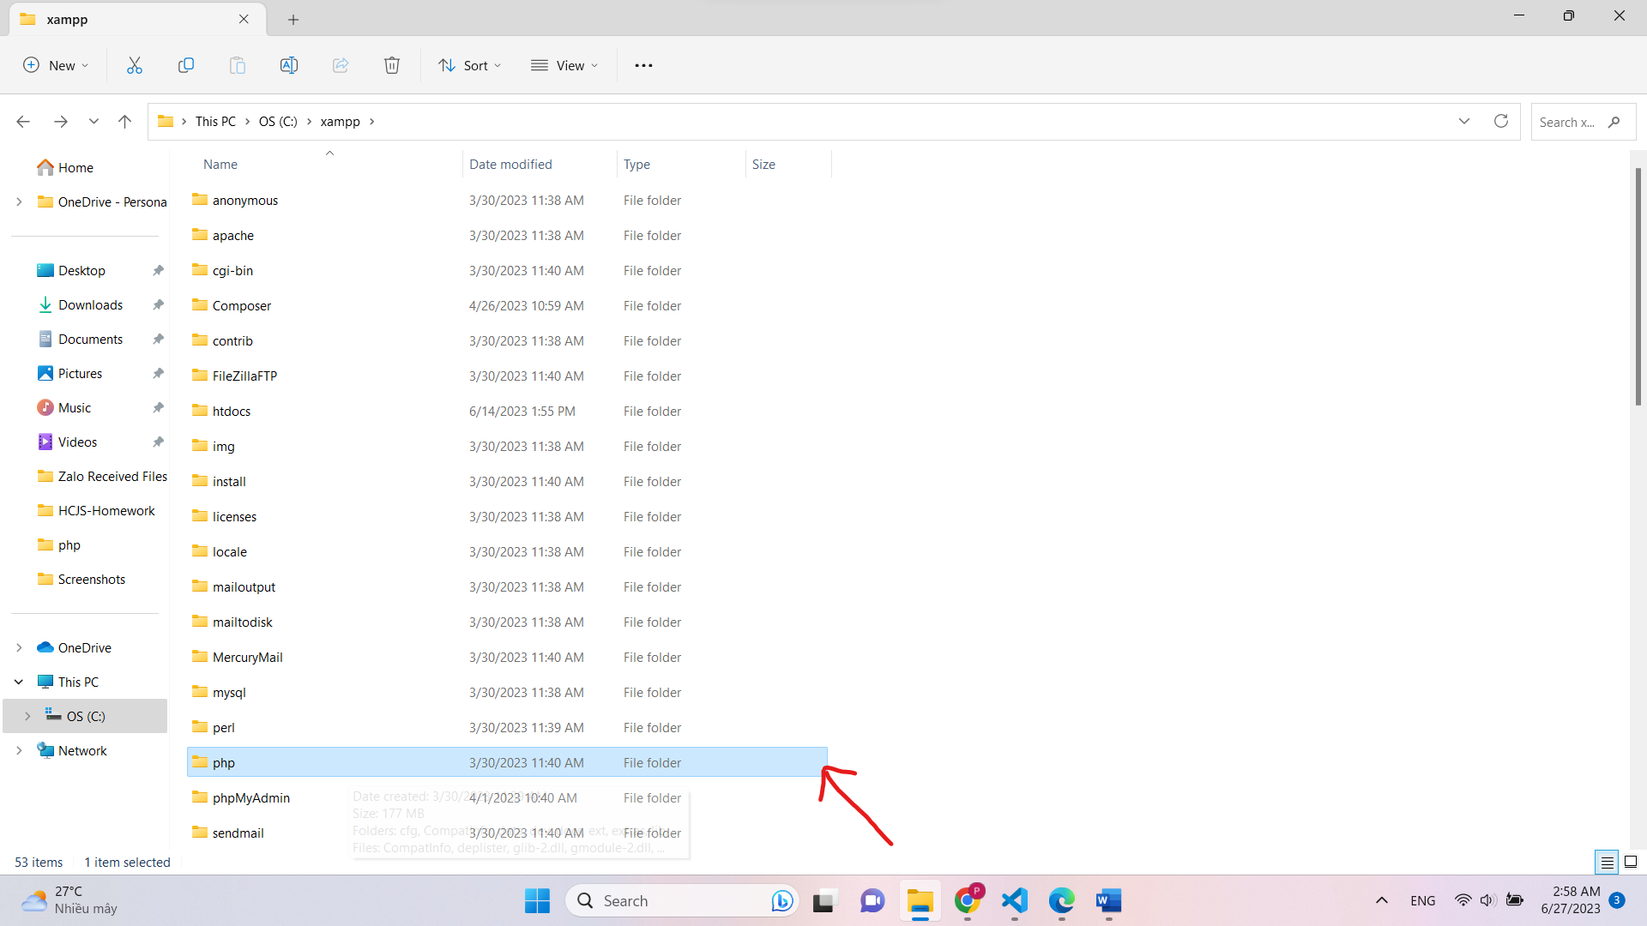

-then open this php 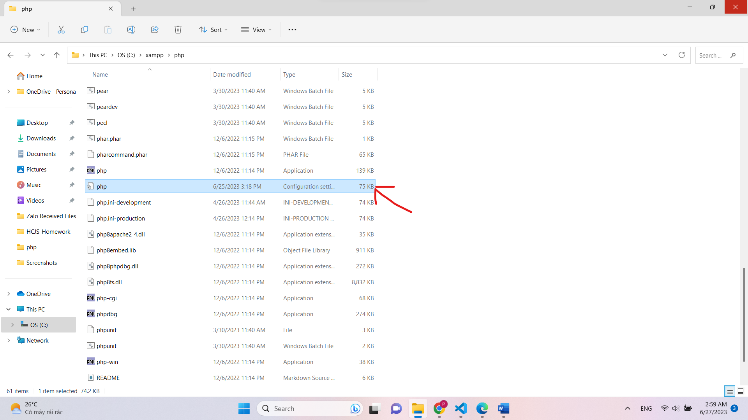

-When the file is opened, you will see an image similar to the one below.

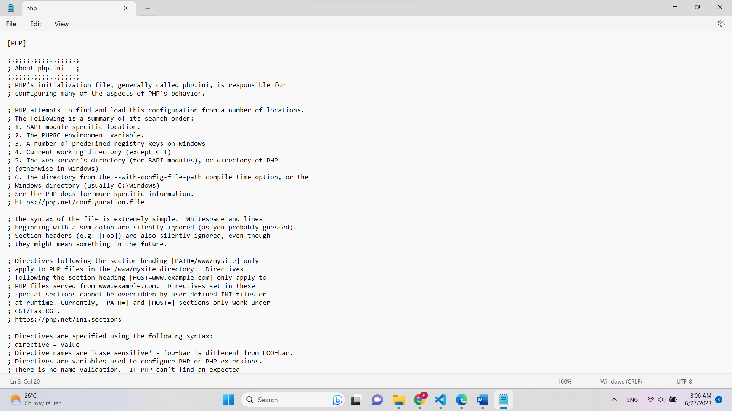

-Then ctrl+F and input gd

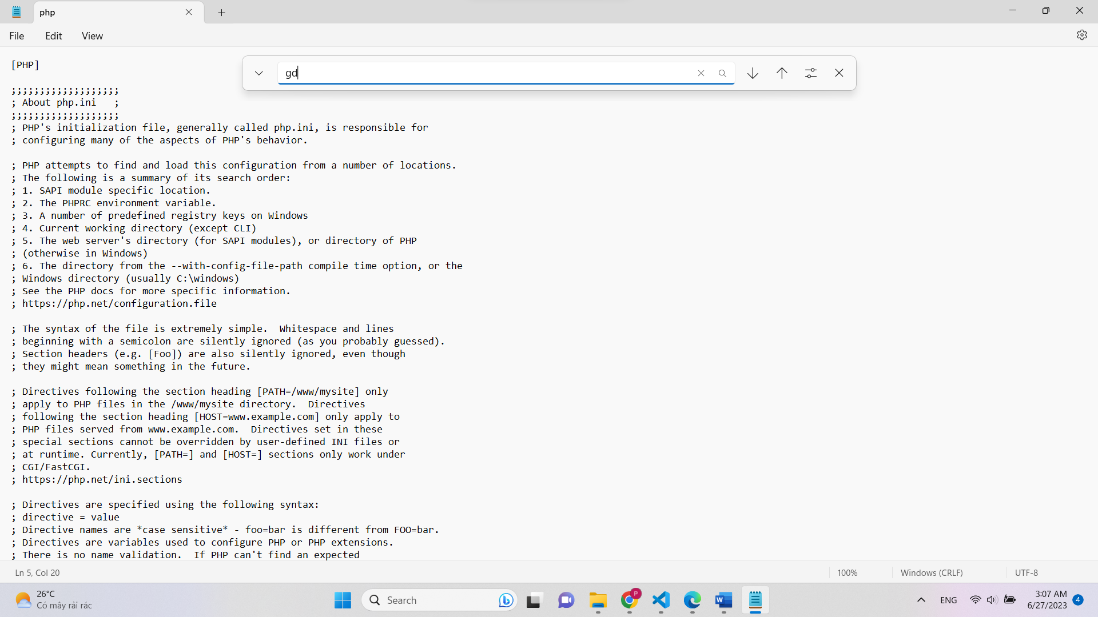

-You will see (;extension=gd)  
-Then delete the first “;”  
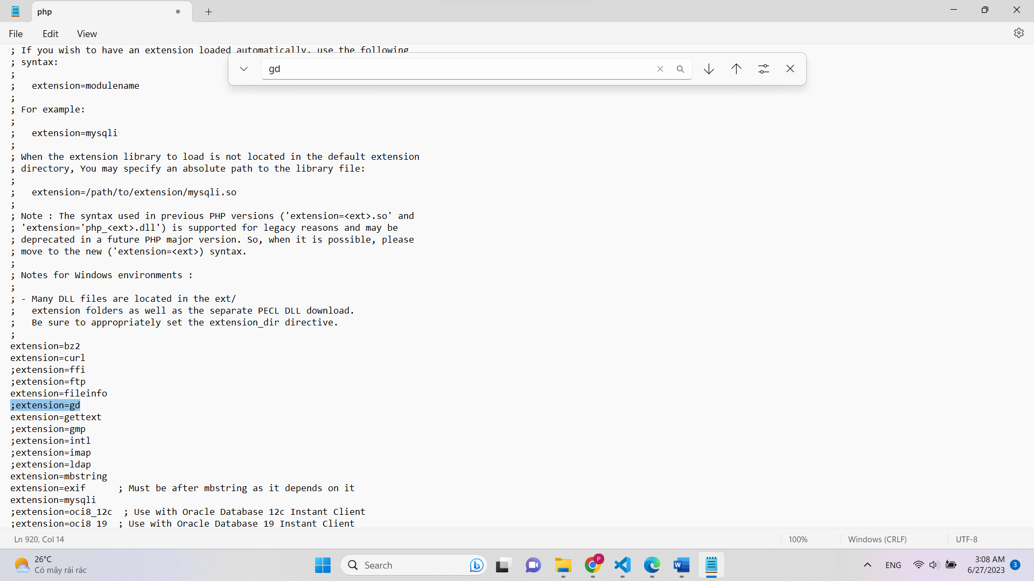

-Now open website and run localhost  
